**Village Tour**

**Group Members:**

* **Ayesha Wasil**
* **Bisal Shafiq**
* **Esha Arif**
* **Ramsha Attaullah Khan**
* **Sana Ahmed**

**Submitted to:**

**Ms. Javeria**

**Table of Content:**

Contents

Game Description: 2

Storyline of the game: 3

Game start: 3

Game Screen 3

Game Over 4

Game Win: 5

Scripts: 6

StartGame.cs: 6

QuitGame.cs: 7

playpause .cs: 7

PlayerScript.cs: 7

PlayerMovement.cs: 8

Obstacle.cs: 8

MouseLook.cs: 9

CoinScript.cs: 10

Gameover.cs: 11

WinScript.cs: 11

Flow Chart: 12

# Game Description:

This game is about Village tour. When you play the game, you will feel like that you are actually touring the village because of its environment and you feel joy by playing this game as you are walking around the village. The core mechanics of this game is to tour the village, collect coins and avoid obstacles. Environment of this game is based on village. We took assets from asset store to create village environment and after adding scripts so that person can play the game and performed actions of moving, collecting coins & avoiding obstacles.

**Storyline of the game:**

Village tour, a casual fun with idle gameplay enables to explore peaceful and tribal environment which is surrounded by nature. The strategy of game design is ludic, tight and well-defined gameplay that focuses on rules and mechanics.

As the game starts, the start screen appears from where the player plays and walks around the village collect coins for scoring of minimum 10 to win the game and avoid colliding from obstacle; Fire wood. If the player collides with obstacle the game over panel will appear along with option of ‘Replay’ or ‘Quit’.

**Screen Shots:**

## Game start:

Here is the screen which shows the start button. By clicking on start button, you can start the game and play it.



## Game Screen

It is the gameplay area which shows the first-person player is walking around the village collects coins. As raising of the score and collecting ten out of zero coins player compete for the win state.

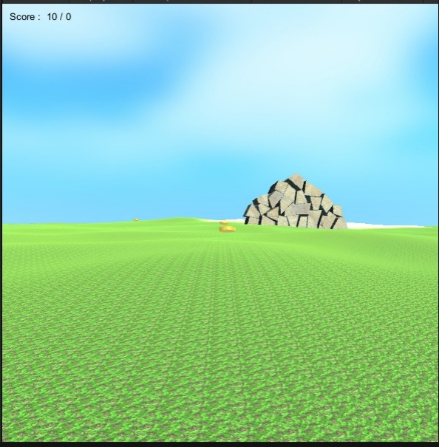

## Game Over

When first person collides with obstacles the game is over and the screen shows two button one is for replay and other is quit if you want to replay the game click on replay button and if you want to quit so click on quit button.

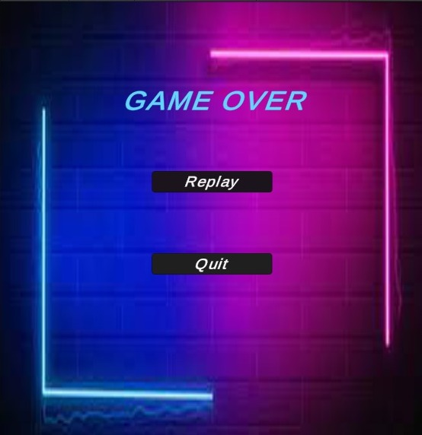

## Game Win:

By avoiding obstacles and scoring of ten coins, for which the script of win state added for the player the game will finish and player will win.



# Scripts:

### StartGame.cs:

using System.Collections;

using System.Collections.Generic;

using UnityEngine;

using UnityEngine.SceneManagement;

public class StartGame : MonoBehaviour

{

// Start is called before the first frame update

void Start()

{

}

// Update is called once per frame

void Update()

{

}

public void LoadGame()

{

SceneManager.LoadScene("SampleScene");

}

}

### QuitGame.cs:

using System.Collections;

using System.Collections.Generic;

using UnityEngine;

public class QuitGame : MonoBehaviour

{

// Start is called before the first frame update

void Start()

{

}

// Update is called once per frame

void Update()

{QuitGamee();

}

public void QuitGamee()

{

Application.Quit();

}

}

### playpause .cs:

using System.Collections;

using System.Collections.Generic;

using UnityEngine;

public class playpause : MonoBehaviour

{

public void PauseGame ()

{

Time.timeScale = 0;

}

public void ResumeGame ()

{

Time.timeScale = 1;

}

}

### PlayerScript.cs:

using System.Collections;

using System.Collections.Generic;

using UnityEngine;

public class PlayerScript : MonoBehaviour

{

public int points = 0;

// Start is called before the first frame update

void Start()

{

}

// Update is called once per frame

void Update()

{

}

private void OnGUI()

{

GUI.contentColor = Color.black;

GUI.Label(new Rect(10, 10, 100, 20), "Score : " + points,"color");

}

}

### PlayerMovement.cs:

using System.Collections;

using System.Collections.Generic;

using UnityEngine;

public class PlayerMovement : MonoBehaviour

{

public CharacterController controller;

public float speed = 12f;

// Update is called once per frame

void Update()

{

float x = Input.GetAxis("Horizontal");

float z = Input.GetAxis("Vertical");

Vector3 move = transform.right * x + transform.forward * z;

controller.Move(move * speed * Time.deltaTime);

}

}

### Obstacle.cs:

using System.Collections;

using System.Collections.Generic;

using UnityEngine;

using UnityEngine.SceneManagement;

public class Obstacle : MonoBehaviour

{

// Start is called before the first frame update

void Start()

{

}

// Update is called once per frame

void Update()

{

}

void OnCollisionEnter(Collision collision)

{

if(collision.gameObject.tag== "Obstacle")

{

LoadGame();

}

}

public void LoadGame()

{

SceneManager.LoadScene("GameOver");

}

}

### MouseLook.cs:

using System.Collections;

using System.Collections.Generic;

using UnityEngine;

public class MouseLook : MonoBehaviour

{

public float mouseSensitivity = 100f;

public Transform playerBody;

float xRotation = 0f;

// Start is called before the first frame update

void Start()

{

Cursor.lockState = CursorLockMode.Locked;

}

// Update is called once per frame

void Update()

{

float mouseX = Input.GetAxis("Mouse X") * mouseSensitivity * Time.deltaTime;

float mouseY = Input.GetAxis("Mouse Y") * mouseSensitivity * Time.deltaTime;

xRotation -= mouseY;

xRotation = Mathf.Clamp(xRotation, -90f, 90f);

transform.localRotation = Quaternion.Euler(xRotation, 0f, 0f);

playerBody.Rotate(Vector3.up * mouseX);

}

}

### CoinScript.cs:

using System.Collections;

using System.Collections.Generic;

using UnityEngine;

public class CoinScript : MonoBehaviour

{

// Start is called before the first frame update

void Start()

{

}

// Update is called once per frame

void Update()

{

transform.Rotate(90 * Time.deltaTime, 0, 0);

}

private void OnTriggerEnter(Collider other)

{

if (other.name == "Player")

{

other.GetComponent<PlayerScript>().points++;

Destroy(gameObject);

}

}

}

### Gameover.cs:

using System.Collections;

using System.Collections.Generic;

using UnityEngine;

using UnityEngine.SceneManagement;

public class Gameover : MonoBehaviour

{

// Start is called before the first frame update

void Start()

{

}

public void LoadGameeee()

{

SceneManager.LoadScene("SampleScene");

}

// Update is called once per frame

void Update()

{

}

}

### WinScript.cs:

# 

# Flow Chart:

**Player is walking around the village**

**Yes**

**Game Over**

**Collide With Obstacles**

**No**

**Collect ten coins out of zero**

**Game finish and player will win**

False